**Homework 1**

**Running the application:**

1. Server:

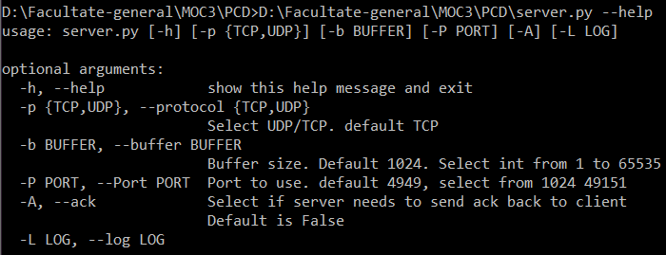

Example: 

1. Client:

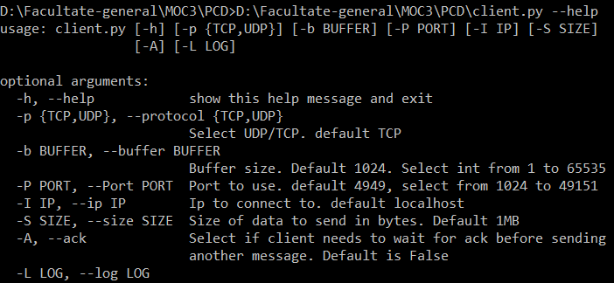

Example: 

**Tests:**

Local – Server and Client on the same machine

|  |  |  |  |  |  |  |  |  |
| --- | --- | --- | --- | --- | --- | --- | --- | --- |
| Protocol | Ack | Buffer Size | Sent  bytes | Received bytes | Lost | Sent messages | Received messages | Time |
| UDP | False | 10 | 10485764 | 10485764 | 0 | 1048576 | 1048576 | 14.7s |
| UDP | False | 1024 | 10485764 | 10485764 | 0 | 10241 | 10241 | 0.14s |
| TCP | False | 1024 | 10485760 | 10485760 | 0 | 10240 | 10240 | 0.16s |
| TCP | False | 10 | 10485760 | 10485760 | 0 | 1048576 | 1048576 | 14.7s |
| TCP | True | 1024 | 10485760 | 10485760 | 0 | 10240 | 10240 | 0.48s |
| UDP | True | 1024 | 10485764 | 10485764 | 0 | 10241 | 10241 | 0.55s |
| TCP | False | 1024 | 2.024GB | 20.24GB | 0 | 1976563 | 1976563 | 33s |
| UDP | False | 1024 | 2.025GB | 2023974916 | 25000 | 1976564 | 1976539 | 33s |

Remote – Server on a machine in Bucharest, Client in Iași

|  |  |  |  |  |  |  |  |  |
| --- | --- | --- | --- | --- | --- | --- | --- | --- |
| Protocol | Ack | Buffer Size | Sent  bytes | Received bytes | Lost | Sent messages | Received messages | Time |
| UDP | False | 10 | 10485774 | 10417954 | 67820 | 1048578 | 1041796 | 43.8s |
| UDP | False | 1024 | 10486788 | 10272772 | 214016 | 10242 | 10033 | 1.6s |
| TCP | False | 1024 | 10486784 | 10486784 | 0 | 11548 | 10241 | 1.6s |
| TCP | False | 10 | 10485770 | 10485770 | 0 | 1048577 | 1048640 | 5.5s |
| TCP | True | 1024 | 10486784 | 10486784 | 0 | 10241 | 10241 | 467s |
| UDP | True | 1024 | 10486784 |  | ack |  |  | >10h |
| TCP | False | 10000 | 1020000 | 1020000 | 0 | 102 | 170 | 0.44s |
| TCP | False | 1000 | 10120000 | 10120000 | 0 | 10120 | 12618 | 24.8s |
| UDP | False | 1000 | 10120004 | 9994004 | 126000 | 10121 | 9995 | 2.2s |